
Dashboard Design

Date | 1 November 2026
Team ID
Project Name | Electric Vehicle Market Performance & Insights
Maximum Marks | 5 Marks

Activity 1: Interactive and visually appealing dashboards
Creating an effective Tableau dashboard involves presenting the EV dataset through clear, relevant, and easy-to-understand visualizations. The dashboard helps users compare important measures, trends, categories and manufacturer performance.
- Clear and Intuitive Layout
- Use Appropriate Visualizations
- Colour and Theming
- Interactive Filters and Slicers
- Drill-Down Capabilities
- Responsive Design
- Custom Visuals and Icons
- Use of Infographics

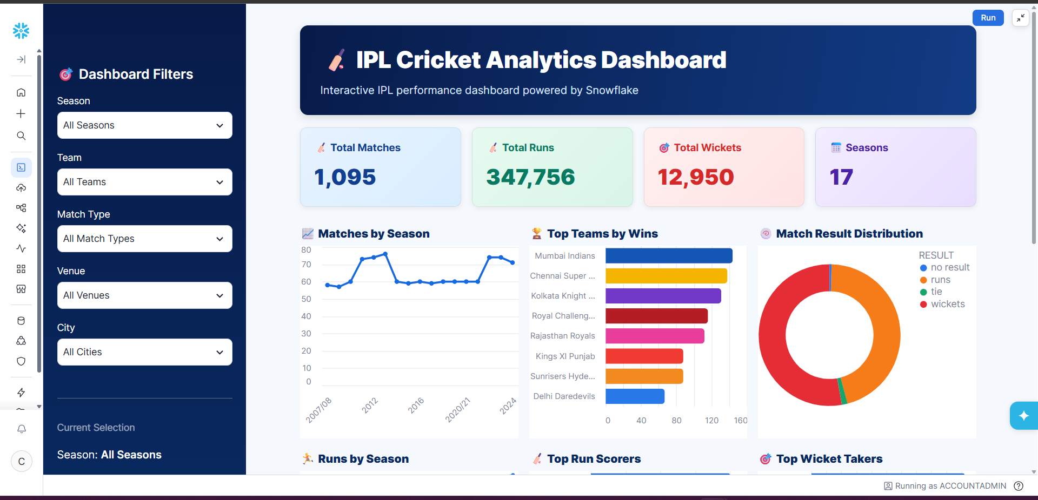
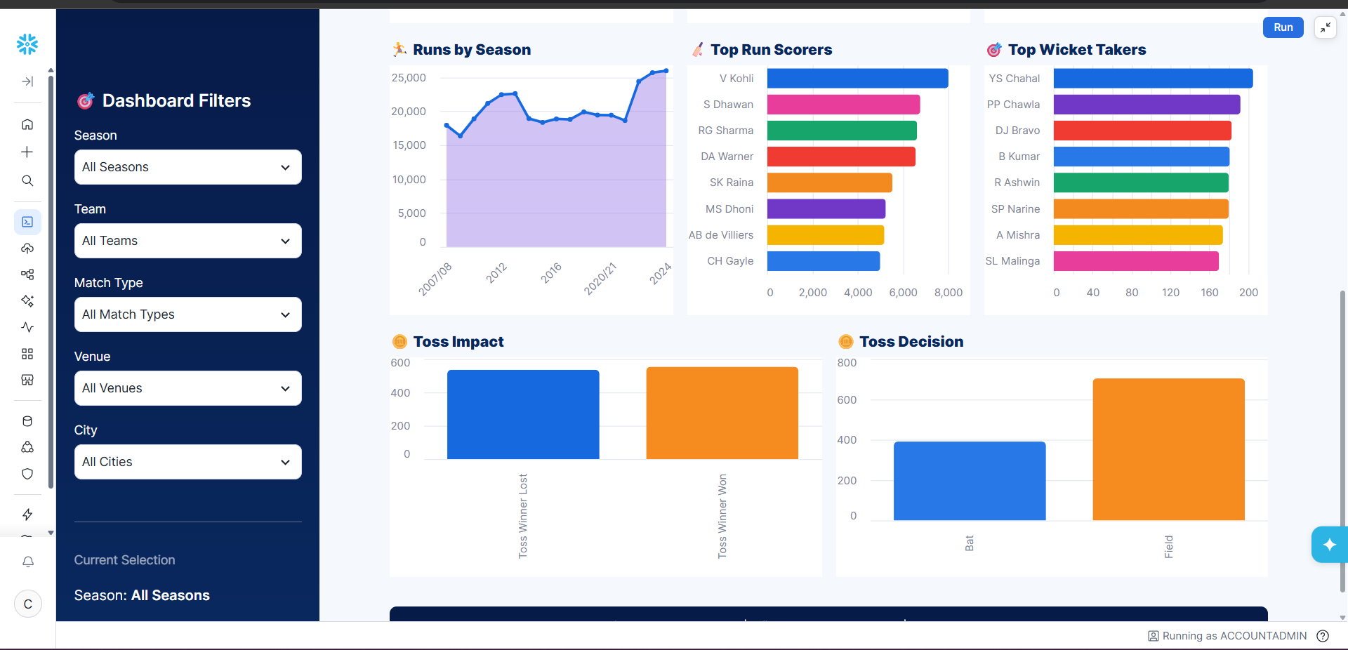
Note: Highlight the major outcomes in form of bullet points
Sample:
Here are five potential outcomes from the dashboard image provided:

Major outcomes from the Tableau dashboard:
Manufacturer comparison: The Top 10 Manufacturers by Annual Sales view ranks the leading manufacturers in the supplied dataset.
Sales trend: The Annual EV Sales Trend view shows how recorded EV sales vary across model years.
Battery mix: The Battery Technology Distribution view compares the technologies represented in the dataset.
Range comparison: Average Driving Range by Vehicle Category makes category-level range differences visible.
Price and range: The scatterplot helps users inspect the distribution and possible association between vehicle price and driving range.
Customer ratings: The manufacturer comparison view makes it easier to compare recorded customer-rating values.
Environmental measure: CO₂ Savings by Manufacturer compares the recorded savings measure across manufacturers.
Geographic distribution: The country map shows where EV manufacturing records are represented.
Implementation note: This template's original wording refers to Streamlit and Snowflake, but this project was implemented in Tableau Public. No Streamlit application or Snowflake backend is claimed.
Published Tableau Public dashboard: https://public.tableau.com/app/profile/amushka.soni/viz/tableu_17931290491940/Dashboard2

